Priorities for the new ERASMUS+ in pandemic times: insights, challenges, and, strategies within the transition to the new Programe 2021-2027
The horizontal priorities for the new programme 2021-2027, translating minor public values, were being anticipated by a specific approach of the PTNA, the ‘NA Transition Plan ’ , to address the programme change. The plan includes action approach to objectives related to education and training internationalization, through mobility and cooperation among institutions; and a horizontal approach, according to priorities and seeking a more inclusive overall practice related to Erasmus+, empowered and increasing synergies among different funding opportunities – including supporting the organizations’ micro synergies -, and enabling the development of digital and greener practices within the Agency as well supporting those practices in projects’ development. This dimensions were targeted in the staff survey and beneficiaries’ survey,, as inputs to strategic alignment (Biggs, Brough & Barboure, 2014) and instruments to measure overall performance.
Alltogether, the pandemic deployed a series of social effects and challenges, showing through the indicators, reflected both in staffs’ overall work engagement and perceptions of strategic alignment and beneficiaries’ participation as an outcome of public service and signs of public value creation (Anderssen, Brewer & Leisink, 2021). This include the overall service, some reflection on issues such as application support, selection, monitoring, the Agency and the Programme brand. Other issues included organizational indicators showing impacts on staffs’ work, or rather how the project lifecycle management was influenced. The beneficiary survey also included an anticipation on how the horizontal priorities were being prepared by beneficiaries – considering this horizontal priorities to be public values transferred from Erasmus+ to the beneficiary organisations, projects and even groups. It should be noted that internal conditions for a greener and more digital work were anticipated by a further-paperless-Agency (Sellen & Harper, 2002), based on mobile ITs and enabling an immediate transition to telework (Chaterjee, Sarker & Siponen, 2017) - or peopleless offices (staff working in digital platforms), and officeless people in digital workplaces (Byström, Ruthven & Heinström, 2017), as staff was temporarily prevented from accessing the office due to the pandemic.
Summing up, in practical terms, the transition between programes emerges in the synchronization of three important issues: i) the pandemic, hitting its highest severity by the time the surveys were passed (January 2021); ii) the preparation of the new programme, a new Programme guide, adjustment of existent rulingand iii) the Transition Plan of the PTNA, promoting the strategic alignment of the organization.
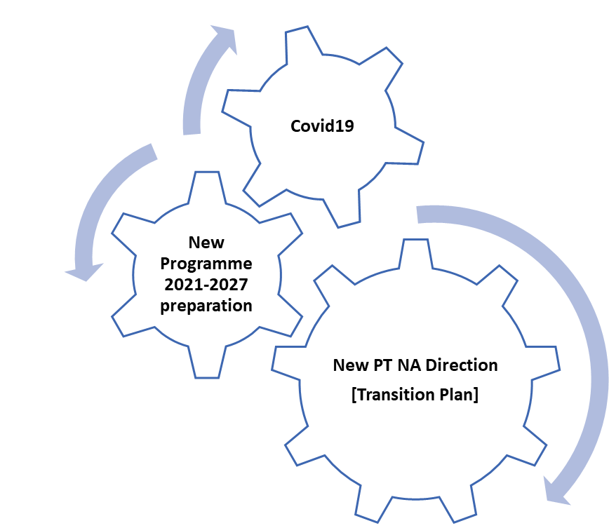
Evaluation is an examination ofselected aspects of the projects implementation to check whether the adopted assumptions and objectives is achieved. Evaluation also allows for a qualitative assessment of the project’s implementacion. Thanks to the evaluation, you can find out, for example, whether participants benefit from taking part in activities, whether the outputs produced are of good quality and feel the needs of the people they are intended to serve, whether the work organisation is optimal, and objectives are met. Key areas need toare investigated in such a way that the information obtained can support the project’s implementation, and, if nesessary, the taking of corrective or remedial measures. Data for such an evaluation can be provided by, among other things, properly planned monitoring. For larger-scale packages of activities and results, it is useful to identify milestones.
Types of evaluation and project life cycle
- Initial (exante) evalation → conducted before the start of the project’s activities, an initial state can be examined, and include: learning outcomes, knowledge of learners and teachers/educators/teachers/trainers, level of specific competencies (e.g. of young people, students, institution staff, adult learners), the quality of the institution’s/organisation’s work as perceived by staff/learners/community, research findings and reports on the industry/sector or topic of the project.
Note: Conducting an initial evaluation is a key element within needs analysis. These processes relate to the same sources of date. By drawing a reliable analysis of an institution's or organisation's needs, the initial evaluation activities are carried out over the same time.

- Interim evaluation (on-going) → is carried out in the course of the project and refers to key activities, i.e. the ones that are the most relevant for the achievement of its objectives.
- Final evaluation (expost) → is carried at the end of the project. It should cover the same areas that were evaluated at the beginning of the project and during its implementation. The goal of the final evaluation is to establish the extent to which the project's objectives is been achieved and to develop apropriate indicators for evaluating the results.
- . Vocational education in Poland

- The aim of the chapter devoted to vocational education is to present the state of this system at the eve of the change related to implementation of the new core curricula for vocational education. Due to the availability of data and analyses coming not only from public statistics but also from quantity and quality research (conducted inter alia as part of systemic projects such as “Vocational School as a School of Positive Choice”) and own analyses, the base year for this evaluation is 2010, so that the presented analysis and conclusions cover the widest perspective on vocational education in the social context (selected data for 2011 are included in the first chapter). Owing to the nature of changes implemented in vocational education, this chapter focuses mainly on functioning of vocational upper secondary schools, including the chosen aspects of the educational offer for adults. The scope of the analysis encompasses basic information on vocational education, considering the historical background, educational offer of schools, including development of curricula and changes in them, the system of external examinations and results achieved by graduates, as well as the perspective on quality assurance mechanisms. We also look at the effects.
- Apprentice and master examinations
- Young people can also gain professional training at craft enterprises. About half of the craft professions can be found in the school classification, the rest are in the classification of professions and specialties for the needs of the labour market. The basis for the vocational exams are standardised examination requirements established by the Polish Craft Association (ZRP), or developed by the Central Examination Board. ZRP is entitled to determine the examination standards forming a basis for the examination only for those professions that are not included in the school classification, but in the classification of professions and specialties for the needs of the labour market.
- Examinations for the title of apprentice and master (hereinafter referred to as the apprentice and master examination) are carried out by examination boards of the craft chambers. As a rule, the board’s chairman and his/her deputy should have a tertiary education and a minimum of six years work experience in a profession which is the object of the examination. The Board is to conduct examinations in the examination teams (consisting of at least four or five members).

- 4.5.1.3. Verifying examinations and qualifying examination
- Professional qualifications (professional or master's title) can also be earned by persons taking a qualifying examination enabling, as the Ordinance provides, "to assess the level of knowledge and skills in the profession which is included in the classification of vocational education professions provided for training in a basic vocational school”.
- The qualifying examination is conducted by the state examination board appointed with the vocational school, the continuing education centre or the practical education centre. Qualifying examinations for a professional title are open to all individuals who have acquired skills related to the profession through the courses, training or work experience. Requirements for those who wish to take the testing examinations and qualifying examinations are defined in Ordinance of the Minister of National Education of 3 February 2006 on the acquisition and supplementing of general knowledge, skills and qualifications in non-school forms of education. This group includes, among others, upper secondary school graduates (or lower secondary). The examinations are held in two stages: theoretical and practical.
- Examination tasks are developed by the examination board and approved by the schools superintendent. Sets of questions include performance standards that are the basis of the examination confirming qualifications. A person who has passed the qualifying examination, receives from the examination board a certificate of obtaining the appropriate professional title or title of a master (which is equivalent to a master's title in the profession corresponding to a particular type of craft achieved before the examination board of the craft chamber).
---
Perhaps the most important changes have taken place at the tertiary level. Until the economical transition began in the 1990s, the proportion of people with this level of education had been relatively low. A number of social, economic and political factors influenced this. One of these was the relationship between educational opportunities and the social status of men and women. Social status was particularly important after the end of compulsory education when young people chose the type of school they would attend next. The decision to attend to a basic job-training school (zasadnicza szkoła zawodowa) or a school leading to the matriculation exam was closely linked to parents' education and occupation throughout the period. A more high social status generally made it easier entering a school with a matriculation certificate (especially a general secondary school - liceum), while a lower status led to a more rapid exit from the education system. This rule, with taking into account other factors that influences individual choices, continued to impact the level of education by social group with varying degrees of intensity until the 1990s. However, it cannot be send that since then social status has ceased to determine the time of leaving school and the type of educrational institution chosen. The educational expansion in the second half of the 1990s is only partly associated with the weakening of selection being affected by social origin. Almost three-quarters of Poles declared their desire to obtain higher education, and there was a systematic increase in the belief among Poles that it was worthwhile to be educated (CBOS , 2017a). Realising these aspiration was allowed by differentiating higher education institutions in terms of prestige, type (public and private), and career chances after graduating. The changes who took place were particularly significant in the area of private education, which absorbed a large proportion of secondary school graduates who were born in the 1980s and early 1990s. With almost thirty per cent of graduates from higher education institutions, these and subsequent cohorts have largely shaped the education structure in Poland at the beginning of the 21st century. Recent years, another shift had been observed in educational choices of young people. Since 2010, two basic measures of educational aspirations - gross and net enrolment rate - show a slowdown in flow of young people into higher education. The former describes ratio of the of students in higher education to the number of persons nominally assigned to this level of education, while the latter reflects the ratio of students in higher education to the population in this age group (19-24 years).

Micro synergies at organizational level can be understood as those already existing, which link with other financing, for different purposes or activities, around the same overall object, such as training courses, research activity, other. For instances, a certain VET course can have ESF funding for its functioning, but some of its trainees might be granted through Erasmus+ to accomplish a traineeship in EU.
The surveys were both active in January 2021: the staff satysfaction survey between the 11th of January and the 1st of February, and the beneficiaries satisfaction survey between the 11st of January and the 27th of January.
, [to be added] .
Mobile ITs (or ICTs) enable five affordances to ease telework, according to Chaterjee, Sarker & Siponen (2017: 2): “mobility, connectedness, interoperrability, identifiability, and personalization”.
The situation of graduates in the labour market
See Ordinance of the Minister of Education of 26 June 2007 on the classification of professions in vocational education (Journal of Laws No. 124, item 860, as amended).
See Ordinance of the Minister of Education of 3 February 2006 on the acquisition and supplementing of general knowledge, skills and qualifications in non-school forms (Journal of Laws of 2006 No. 31, item 216).

